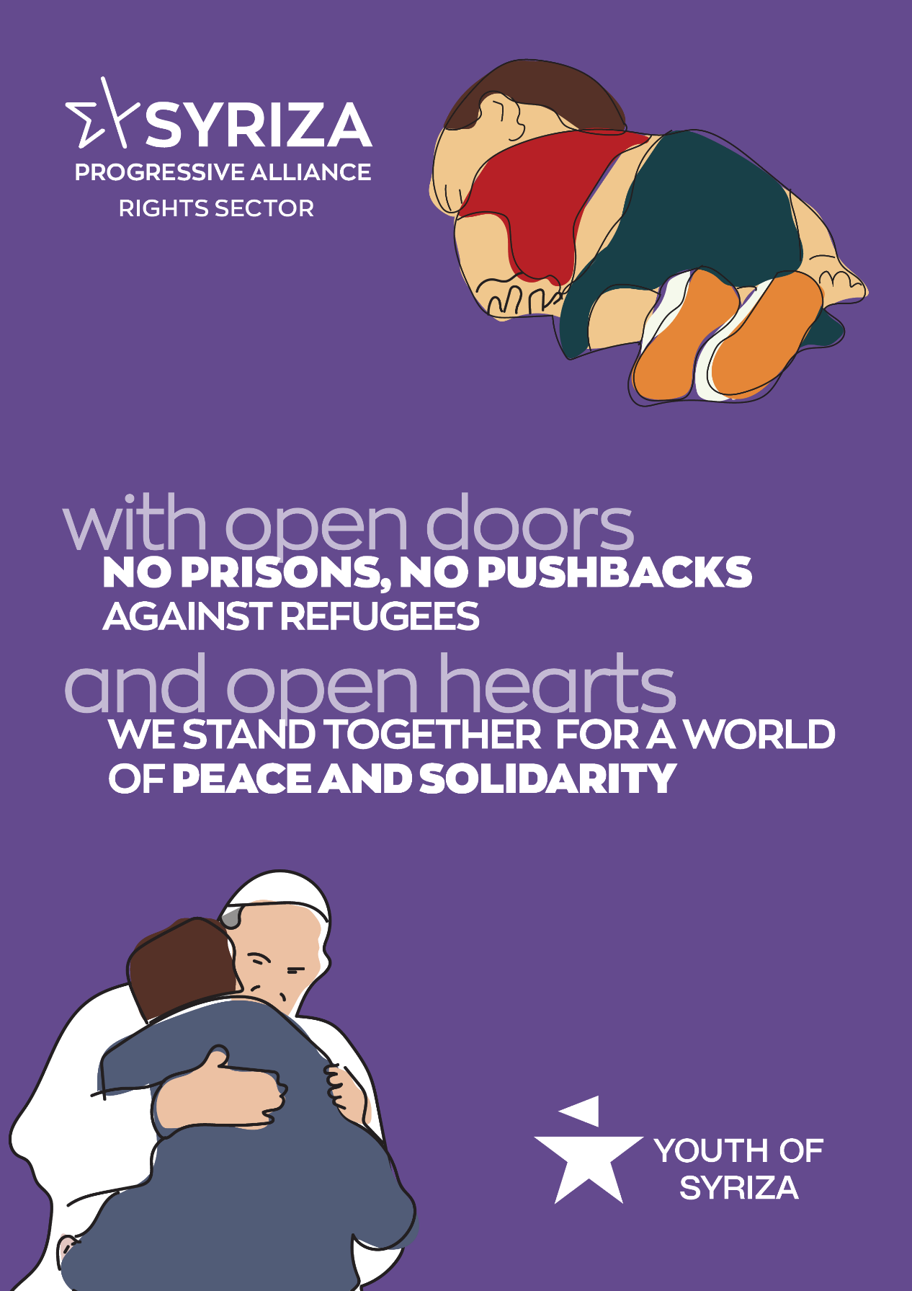

Your Holiness,
It is with sincere emotion that we are often informed of your interventions in favour of the vulnerable of the earth, refugees and immigrants, environmental issues, global peace, the defense of the rights of all people.
In recent years, we have been witnessing with sadness, anger and despair - mainly on the issue of immigration- inhumane behavior by most European governments and the EU itself, which, hypocritically declares to defend the rights of the vulnerable and the struggle for peace, meanwhile participating in wars and mercilessly treating people fleeing wars, droughts, authoritarian regimes, poverty and hunger.
Since July 2019, official rhetoric has been changed in Greece as well. Our country has been turned from solidarity refuge into a place of pain and suffering for whoever -beggar and misfortunate- cross its borders or disembark on its shores. They often do not even manage to disembark, as they are pushed back to Turkey in a ruthless way or, even worse, they end up drowned at the bottom of the sea.
Our open doors have been transformed into an inaccessible wall that "protects" Europe - a fortress against defenseless people, women, men, infants.
As you may have read in the letter sent to you by 36 Non-Governmental Organizations, the few standardized as decent accommodation structures have already been abandoned and all open / accessible reception structures are turned to closed ones, literally into detention camps.
At the moment, into these so-called reception structures, people often physically - let alone psychologically - traumatized, suffer from hunger and cold, deprived from any access to healthcare, education, employment, future.
Our country is currently facing health, economic and social crisis, increasing homicides against women, racist attacks, a sharp rise of police violence and a dramatic reduction in social protection.
Due to all these reasons, we strongly believe that your solidarity and protection of the weakest is more than ever valuable and necessary. You are going to find us on the same path when it comes to equality and justice for all. We never give up; we keep on struggling.

